Lab 8B – Practical REST API Integration Turning API Data into Useful Apps
1. Lab Title & Overview
Overview:
In this lab, students will build a small but practical Flutter app that consumes a real-world public REST API and uses the data for a meaningful purpose, not just as a simple list.
Students can choose one of the following scenarios (or more, for extra credit):
- Weather Companion App – Use a weather API to help users decide what to do or what to wear.
- Movie & TV Explorer – Use a movie API to help users find something interesting to watch.
- (Optional) Currency Rate Helper – Use an exchange rate API to support simple travel or shopping decisions.
The lab reinforces everything from Module 8:
- HTTP + REST
- GET requests
- JSON parsing → model classes
- FutureBuilder + ListView / UI
- Loading & error states
- Service Layer pattern
2. Learning Objectives
After completing this lab, students will be able to:
- Integrate a real public REST API into a Flutter app.
- Convert JSON responses into Dart models that are easy to use.
- Design a purpose-driven UI where API data helps users make decisions.
- Implement loading, empty, and error states with a good UX.
- Organize networking code with a service layer for better structure.
3. Scenarios (Choose at least 1)
3.1 Scenario A – Weather Companion App
Goal of the app (real-world use):
Help the user answer questions like:
- “Do I need an umbrella today?”
- “Is it a good day for outdoor activities?”
- “How hot/cold will it be this afternoon?”
Suggested Features:
- Let the user:
  - Search or choose a city/region
  - View current temperature, weather description, and maybe an icon
  - See short info like “Feels like…”, “Wind speed…”, or “Humidity…”
- Use weather information to show:
  - A simple recommendation:
    - “Take an umbrella” / “No umbrella needed”
    - “Too hot for outdoor sports” / “Nice weather for a walk”
API Examples (for documentation purposes):
- Open weather APIs (e.g., Open-Meteo, OpenWeatherMap, etc.)
(Teacher can suggest 1–2 concrete endpoints in class.)
3.2 Scenario B – Movie & TV Explorer App
Goal of the app (real-world use):
Help the user quickly discover something to watch tonight.
Suggested Features:
- Fetch a list of:
  - Trending movies
  - Popular TV shows
  - Or top-rated content
- Let the user:
  - Scroll through a list of titles + poster + rating
  - Tap on an item to see more details (overview, year, rating)
- Optional:
  - Add a simple “Watch later” / “Favorites” marker
  - Filter by rating or genre (client-side filter)
API Examples:
- Movie DB-style APIs (e.g., TMDB)
(Teacher may provide a shared API key or use a demo endpoint in class)
3.3 (Optional) Scenario C – Currency Rate Helper
Goal of the app (real-world use):
Support basic decisions like:
- “If I have X VND, how much is that in USD?”
- “Is this price high compared to another currency?”
Suggested Features:
- Fetch latest exchange rates for a base currency (e.g., USD or EUR)
- Let the user:
  - Input an amount
  - Choose a target currency
  - See converted value
- Optional:
  - Show a short hint:
    - “Good time to buy” / “Rate is higher than average” (simple heuristic)
API Examples:
- Free exchange rate APIs (e.g., exchangerate.host, Frankfurter, etc.)
4. Functional Requirements (for all scenarios)
Regardless of the scenario chosen, the app must:
- Call a real REST API
  - Use http package
  - Handle network errors gracefully
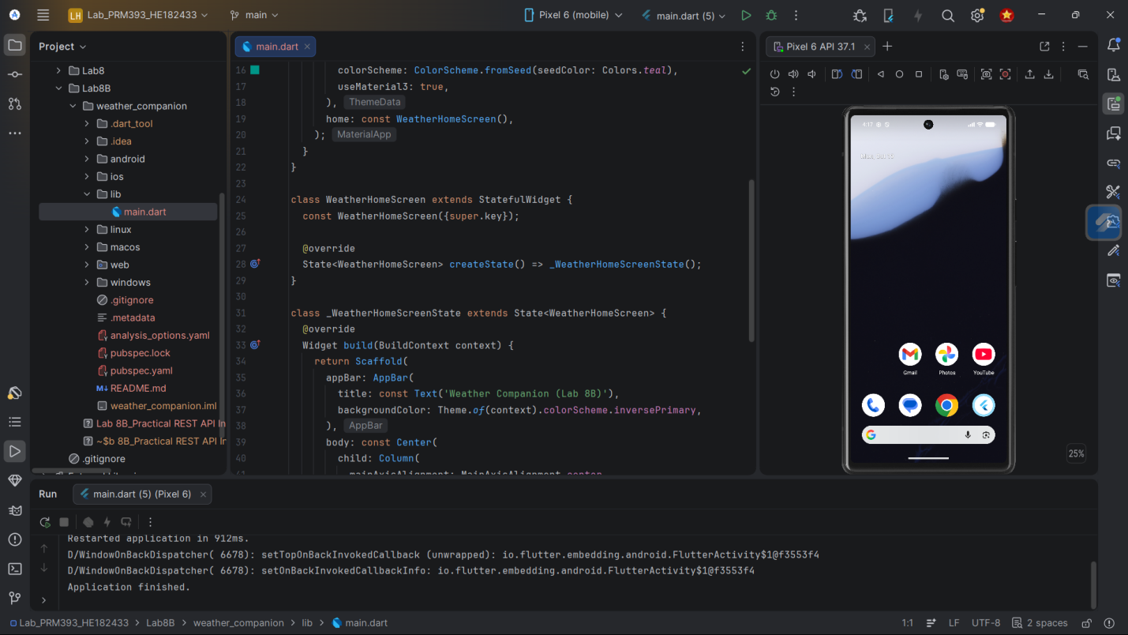
- Parse JSON into model classes
  - Use at least one Dart model class with fields + fromJson
  - Avoid using raw dynamic maps all over the UI
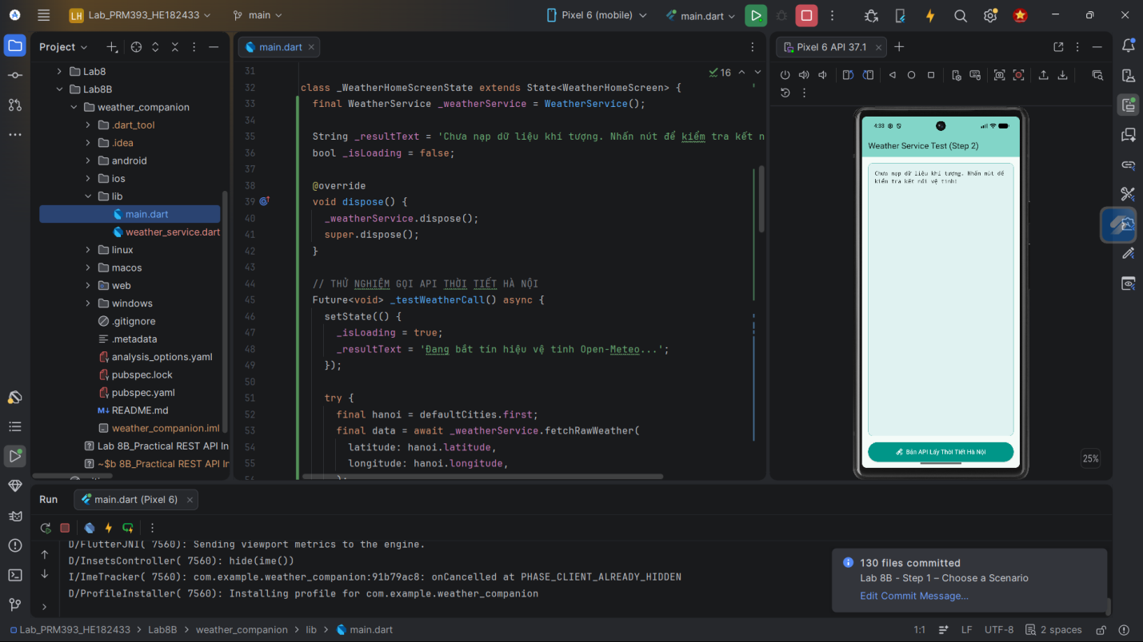
- Display data with a meaningful UI
  - Use cards, tiles, or sections that clearly show important information
  - Not just a debug Text(response.body)
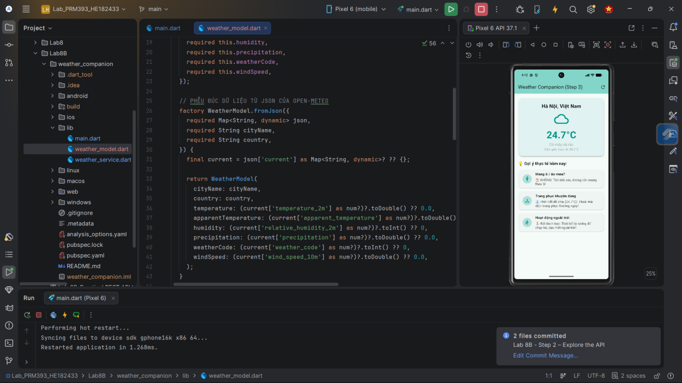
- Handle loading & error states
  - Show a loading indicator while waiting for API
  - Show an error message and a Retry action if the call fails
  - Handle empty or unexpected responses
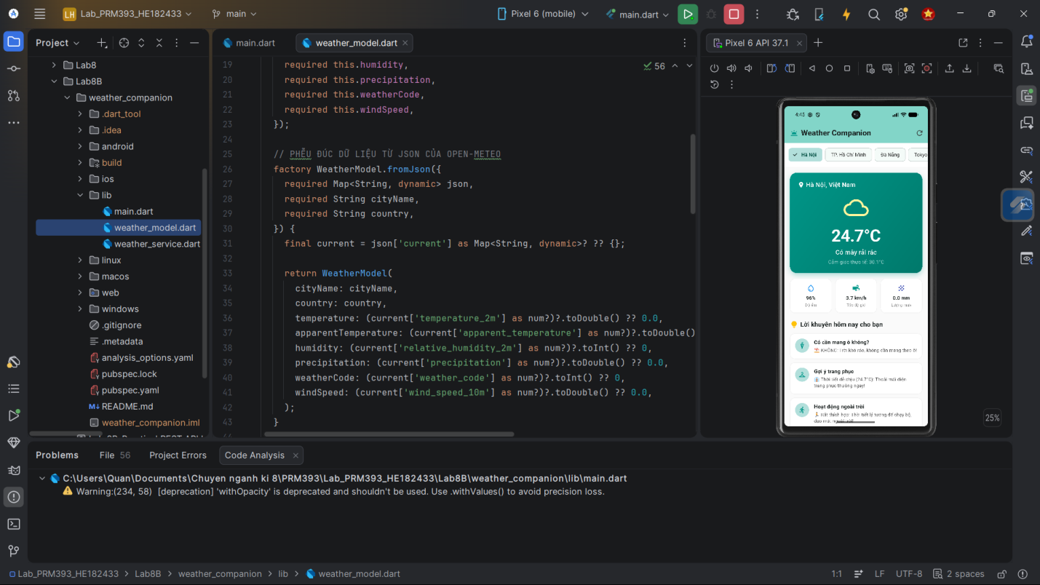
- Use a Service Layer
  - Separate API calls into a dedicated service class
  - Screens/widgets should call service methods, not http directly
5. Technical Requirements
- Flutter project (can be reused from Lab 8 or created new)
- Use http package for all network calls
- Use Future / async/await for asynchronous operations
- Use FutureBuilder or equivalent pattern for binding API data to UI
- Use at least:
  - 1 model class
  - 1 service class
  - 1 main screen
(Optional but recommended):
- Detail screen
- Basic form (for search, filters, or user input)
6. Suggested Lab Steps (For Students)
Step 1 – Choose a Scenario
Pick Weather, Movie, or Currency (or another approved by the instructor).
Step 2 – Explore the API
- Read the API docs
- Identify:
  - Base URL
  - Endpoint
  - Required parameters
  - JSON response structure
Step 3 – Design the UI (Paper or Figma-level, simple)
- Decide:
  - What information you want to show
  - How it helps the user make a decision
  - Where loading / errors will appear
Step 4 – Define Model Classes
- Identify key fields from JSON (id, title, temp, rate, etc.)
- Create model structure on paper or in code (but lab document không cần code).
Step 5 – Plan the Service Layer
- Decide function names like:
  - fetchWeatherForCity
  - fetchTrendingMovies
  - fetchExchangeRates
- Clarify input → output:
  - Input: location / query / base currency
  - Output: List<Model> or a single Model
Step 6 – Integrate Into UI
- Use FutureBuilder to:
  - call the service
  - show loading/error/data
- Map model data → UI widgets (cards, list tiles, text, icons).
Step 7 – Add a “Purpose-driven element”
- For Weather: “recommendation text” (bring umbrella?, good for running?)
- For Movies: highlight top N choices, or mark favorites
- For Currency: show converted value + simple hint
7. Deliverables & Submission
Students must submit:
- App description (short):
  - Which scenario they chose
  - What problem their app helps the user solve
- Screenshots:
  - Loading state
  - Error state (e.g., when network off or invalid URL)
  - Successful data display screen
  - Any optional features (favorites, form, recommendation text, etc.)
- Source code (project or repository link)
  - main.dart
  - model file(s)
  - service file(s)
  - main screen(s)
(Trong file lab, bạn chỉ mô tả yêu cầu; code sinh viên tự làm như các lab trước.)
8. Evaluation Criteria (for teacher)
You can reuse khung chấm của Lab 8, tinh chỉnh nhẹ:
Category | Weight | Description
API Integration | 25% | Correct use of HTTP + endpoint, API actually called
JSON & Model Design | 20% | Good mapping JSON → Dart models
UI & UX | 20% | Data clearly presented, purpose-driven, not just raw text
Async Handling | 20% | Loading, error, retry states, no crashes
Architecture | 10% | Service layer, separation of concerns
Creativity | 5% | How meaningful/interesting the scenario & decisions are

